Student name:

1 A simple experiment measures the length of time in hours that a certain drug is retained in a patient’s system. The following preliminary data were recorded:
$$1.3 1.6 0.8 2.7 3.4 2.6 2.5 3.7 3.9 2.2$$
$$4.5 4.7 4.8 5.1 5.3 5.5 4.9 6.2 6.7 7.4$$
a Complete the following table for these data.
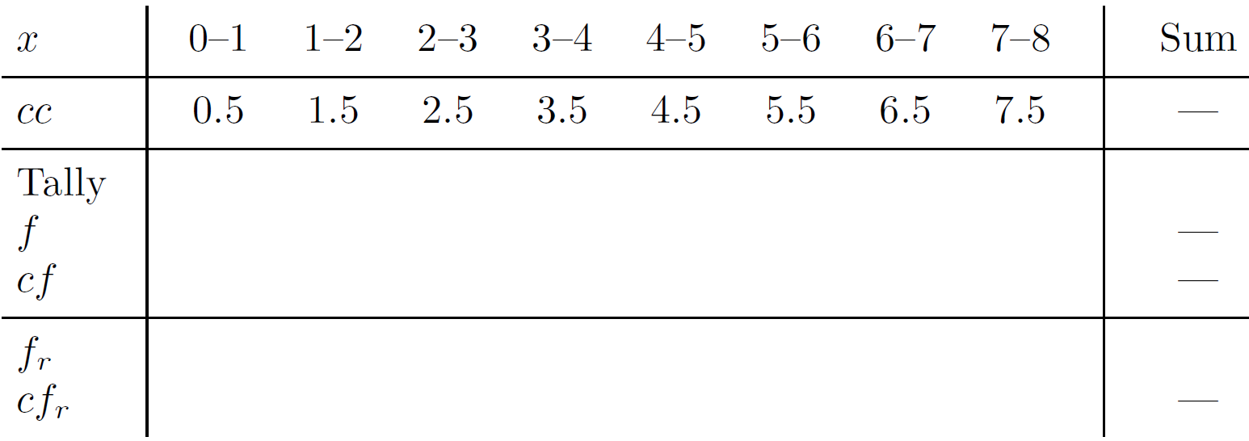
b Draw a relative frequency histogram and polygon for the dataset.
c Draw a cumulative relative frequency histogram and polygon (ogive) for the dataset.
d By adding appropriate horizontal lines to your graph, find:
i the median $Q_{2}$
ii the quartiles $Q_{1}$ and $Q_{3}$
iii the ninth decile
iv the eighty-fifth percentile.
e The dataset appears (almost) bimodal, with many data points falling in two specific intervals. Advise the medical researcher how to proceed next.

2 State whether each of these sentences is true or false.
a The ogive is joined to the top centre of each rectangle of the cumulative frequency histogram.
b The area under the frequency polygon is 1.
c The probability density function of a continuous probability distribution is the analogue of the relative frequency polygon of a discrete distribution.
d A probability density function $f\left(x\right)$ defined on the interval $a≤x≤b$ satisfies the two conditions $f\left(x\right)≥0$, for all $x$ in the interval, and $\int_{a}^{b}{f\left(x\right)}dx=1.$
e Every normal distribution is related to the standard normal distribution by stretches and a horizontal shift.
f Approximately 99% of all data lie within three standard deviations of the mean.

3 Let $f\left(x\right)=\frac{1}{30}$, where $-15≤x≤15$.
a Show that $f(x)$ is a probability density function.
b What special name is given to this type of distribution, where the density function takes the same value across its domain?
c Calculate its expected value.
d Calculate its variance and standard deviation.

4 Let $f\left(x\right)=\frac{4}{243}\left(27-x^{3}\right),$ $0≤x≤3$.
a Show that $f(x)$ is a probability density function $(PDF)$.
b Find its cumulative density function $(CDF)$.
c The CDF is graphed below.
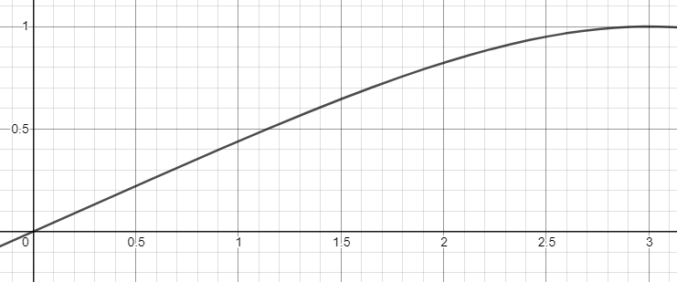

Use this graph to estimate:
i the three quartiles $Q_{1}$, $Q_{2}$ and $Q_{3}$
ii the sixth decile
iii $P(X≤2.3)$
iv $P(X≥0.6)$
v $P(0.4≤X≤0.8)$.

5 Use your standard normal table and a knowledge of the symmetry of the curve to find:
a $P(Z≤0)$ b $P(-1.4≤Z≤1.4)$ c $P(Z≤-0.6)$
d $P(Z≤1.7)$ e $P(Z≥0.2)$ f $P(-0.3≤Z≤1.5)$

6 Find the given probability for the normal distribution with given mean and standard deviation. Use the empirical rule (the 68-95-99.7 rule) to estimate:
a $P(X≤20)$ if $μ=15$, $σ=4$
b $P\left(X≥4.5\right)$ if $μ=8$, $σ=5$
c $P(4.35≤X≤7.56)$ if $μ=7$, $σ=0.1$
d $P\left(11.89≤X≤12.11\right)$ if $μ=9$, $σ=1.2$

7 Find the given probability for the normal distribution with given mean and standard deviation, but use your standard normal distribution tables.
a $P(X≤27.5)$ if $μ=30$, $σ=5$
b $P\left(X≥76\right)$ if $μ=8$0, $σ=10$
c $P(4.88≤X≤5.60)$ if $μ=5$, $σ=0.3$
d $P\left(9.47≤X≤11.15\right)$ if $μ=8$, $σ=2.1$

8 A washing machine manufacturer has tested the design of its machines and found the results to be normally distributed with an expected life of 11 years and 3 months with a standard deviation of 30 months.
a If a family buys one of their machines, what is the probability that it will last more than twelve years?
b The manufacturer is deciding on whether to launch a promotion and advertise a nine-year warranty on its machines. How many machines could they expect to come to the end of their life within the nine-year period?

Answers
1 a
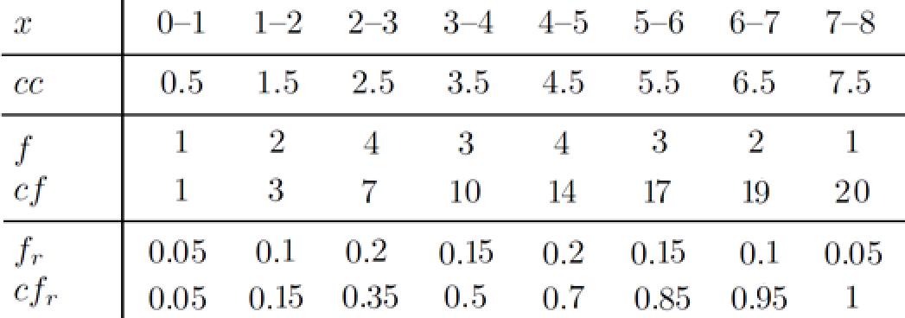
b

c

d From the graph in part c, approximate values are:
i $Q_{2}=3.5$
ii $Q_{1}=2.0$, $Q_{3}=5.0$
iii 6.5
iv 5.5
e This was only a preliminary experiment, and a larger dataset may resolve the unusual outcomes. It may be worth investigating any common links between patients falling in the two intervals associated with the two modes – perhaps different sexes react differently to the drug, perhaps it was administered differently, or perhaps the two groups are behaving differently after medication, for example, changing their levels of follow-up exercise of their food intake.
2 a False, it joins to the right end.
b False. The area under the relative frequency polygon is 1 if the rectangles each have width 1.
c True
d True
e True
f The empirical rule says 99.7% and only applies to a normal distribution, so false in general.
3 a $F\left(x\right)=\int_{-15}^{15}{\frac{1}{30}}dx=\frac{1}{30}\left[15-(-15)\right]=1$.
b A uniform probability distribution with a uniform probability density function.
c $E\left(X\right)=0$
d $E\left(X^{2}\right)=Var\left(X\right)=75$, $σ=5\sqrt{3}$
4 a $F\left(x\right)=\int_{0}^{3}{f(x)}dx=\int_{0}^{3}{\frac{4}{243}\left(27-x^{3}\right)}dx=\frac{4}{243}\left[\left(81-\frac{81}{4}\right)-(0)\right]=\frac{4}{243}×\frac{243}{4}=1$
b $F\left(x\right)=\frac{1}{243}x(108-x^{3})$, $0≤x≤3.$
c i $Q_{1}=0.55$, $Q_{2}=1.15$, $Q_{3}=1.8$0
ii 1.4
iii 0.9
iv 0.75
v 0.18
5 a 0.5
b 0.8385
c 0.2743
d 0.9554
e 0.4207
f 0.5511
6 a 89%
b 76%
c 100%
d 0.35%
7 a 0.3085
b 0.6554
c 0.6326
d 0.1752
8 a Let $X$ be the lifetime in years of a machine $P\left(X>12\right)=P\left(Z>0.3\right)=0.3821$
b $P\left(X<9\right)=P\left(Z<-0.9\right)=18.41\%$. This is probably an unacceptable risk for the manufacturer, and they should increase the mean life, or decrease the standard deviation, or adjust the length of their advertised warranty.

